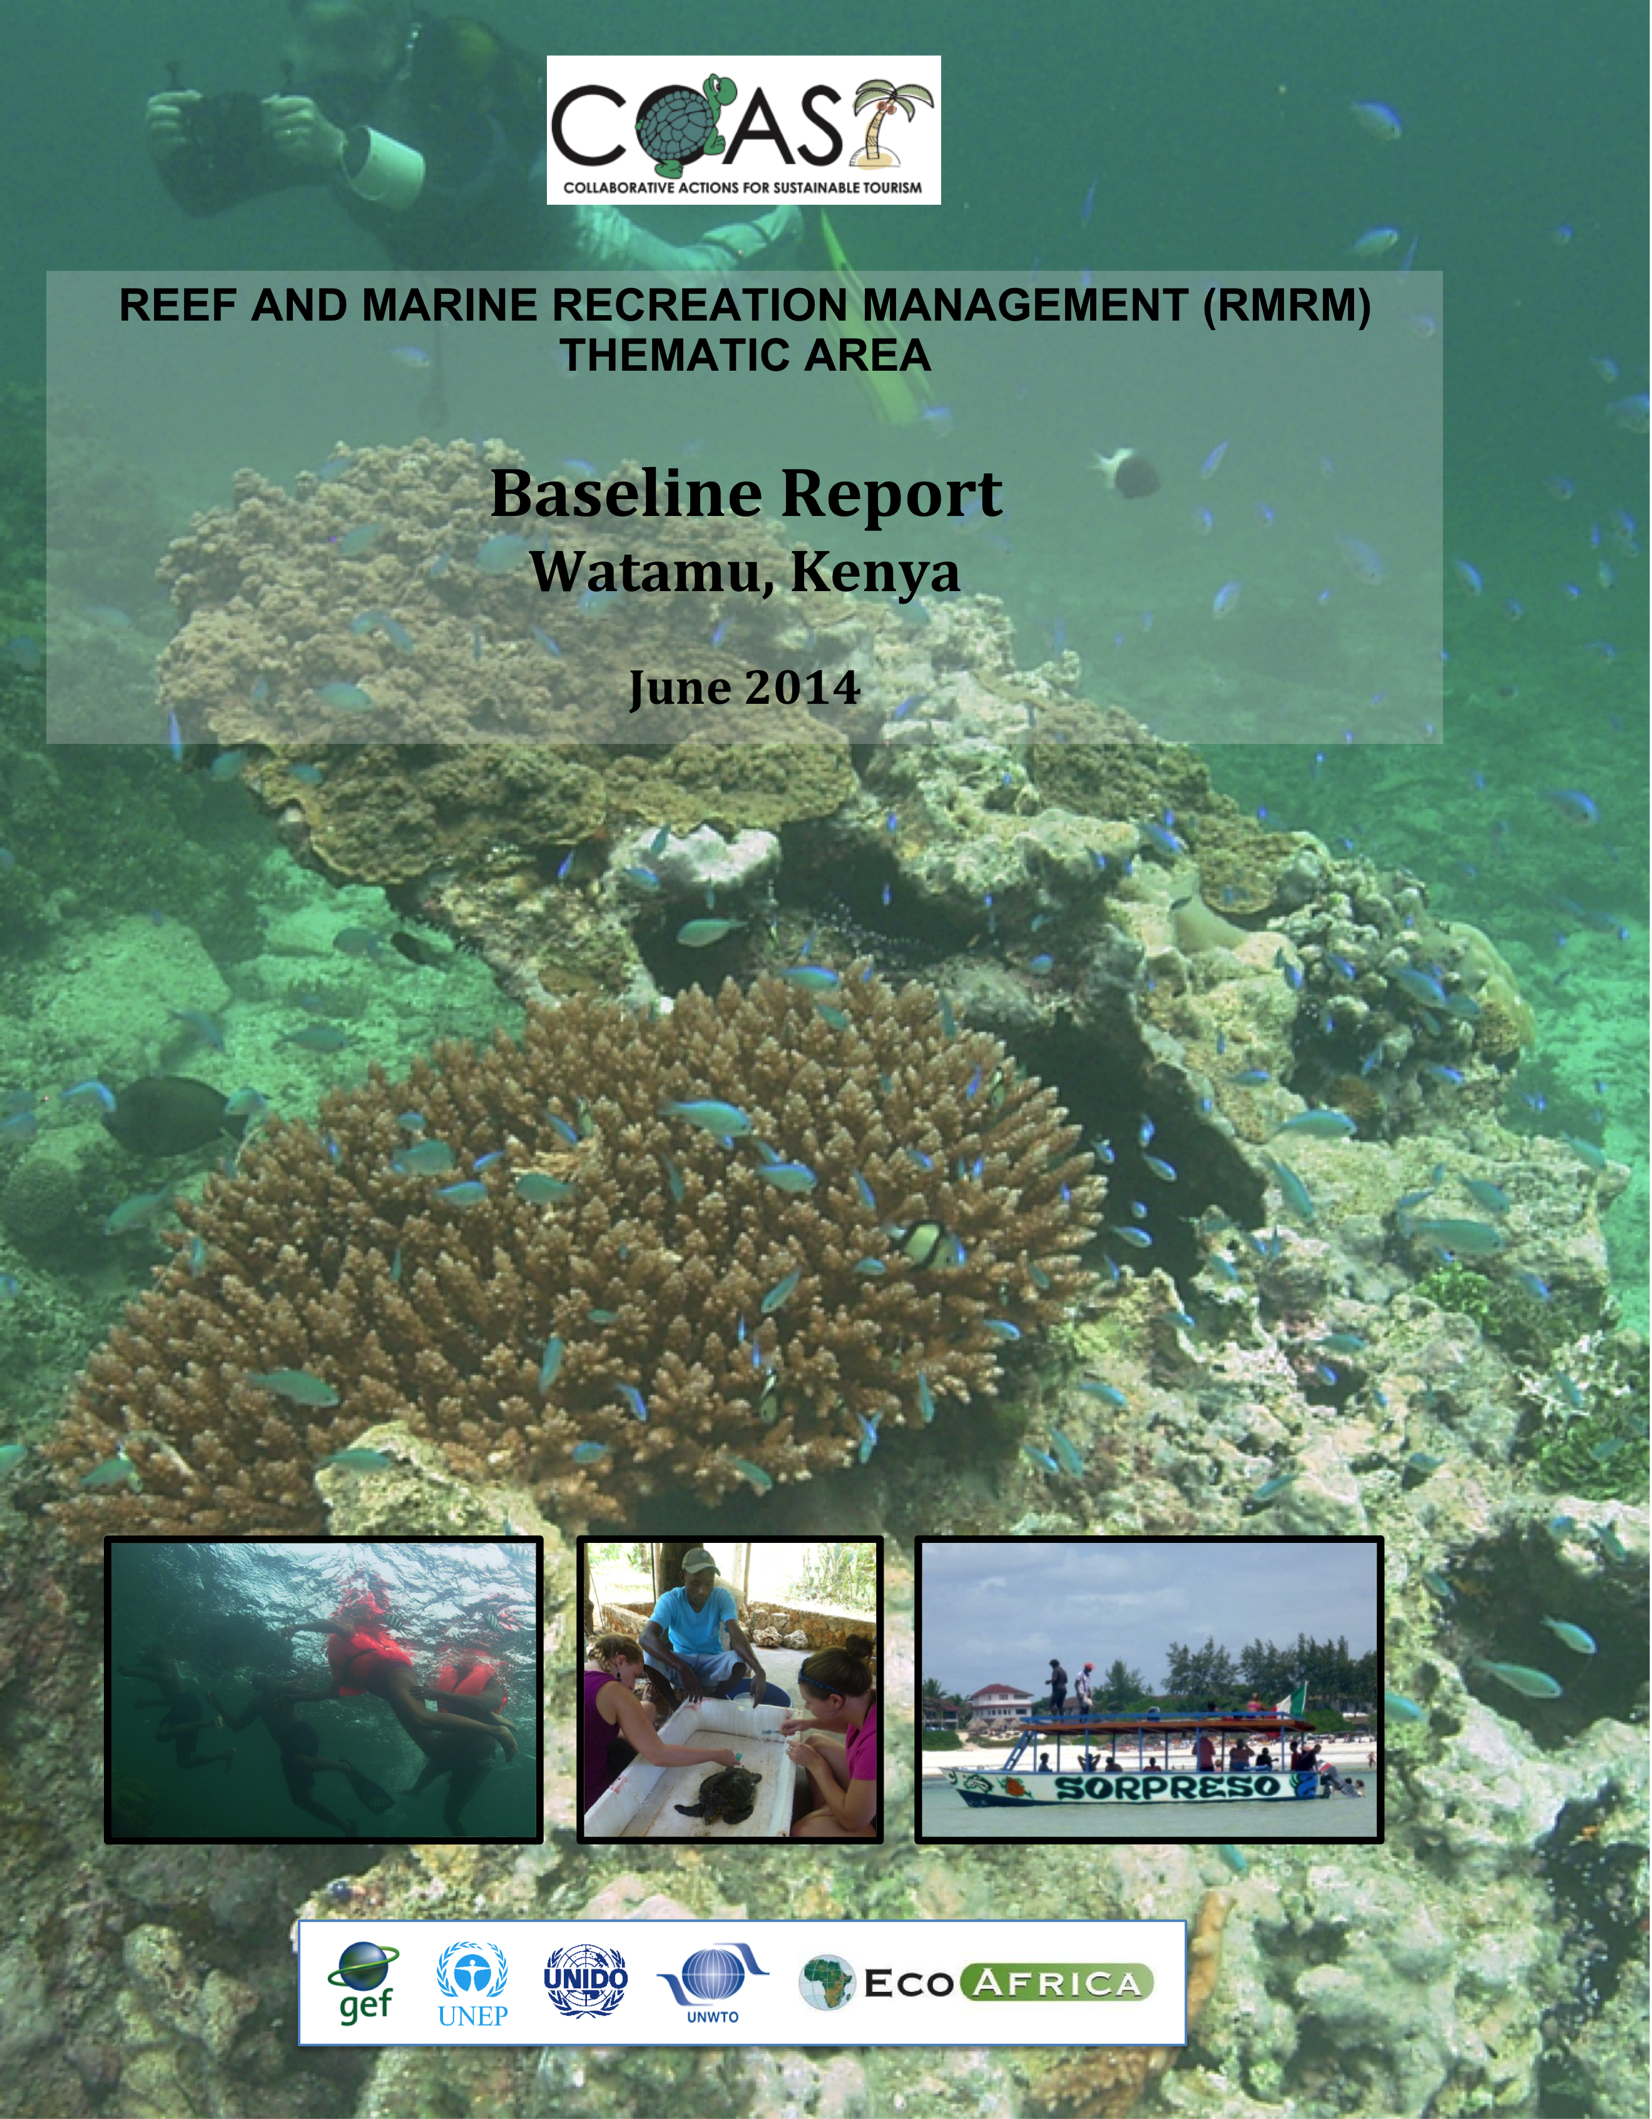

COLLABORATIVE ACTIONS FOR SUSTAINABLE TOURISM PROJECT
REEF AND MARINE RECREATION MANAGEMENT THEMATIC AREA

BASELINE REPORT
WATAMU, KENYA

June 2014

By:
Bernice Mclean*
Jonathan Kingwill*
Jayshree Govender*
Violet Njambi Ogega*

In collaboration with the COAST Demo Site Management Committee and other stakeholders

* EcoAfrica Environmental Consultants

Executive Summary
Watamu Demonstration site is one of three demonstration sites in the Reef and Marine Recreation Management (RMRM) component of the Collaborative Action for Sustainable Tourism (COAST) Project. Watamu is located within the Malindi District (Kilifi County), in the Coast Province of Kenya. This region is one of the main recreational centres of Kenya and is one of the best-known reef areas of the Kenyan coast. Major attractions include boat trips, water sports, deep-sea fishing and coral viewing. The site has unique habitats and a rich diversity of marine life forms.
This Baseline Report was developed based on results from an initial stakeholder survey undertaken to inform the project activities between 11th and 20th October 2011, as well as findings emerging during the implementation of the project activities and a second stakeholder survey undertaken at the end of the project during May 2014. The primary aim of the initial baseline survey was to record issues relating to the social economic status of the people in the area, establish sensitive/damaged mangrove and reef sites, and to determine the best way to communicate with local stakeholders in the Reef and Marine component of the COAST Project. The aim of the second survey was to obtain perceptions from stakeholders who had been directly involved in the Reef and Marine Recreation Management (RMRM) Thematic Area activities on ongoing challenges and priorities. In both surveys, structured questionnaires were used. Additional findings emerging from the implementation of the RMRM project activities are also included in this document.
Key findings emerging from the RMRM activities include:
- Awareness of the value of the ecological goods and services provided by healthy and productive coastal and marine ecosystems is low, as is the value and potential for tourism development in the area;
- Ecosystem change and degradation exists in some of the higher-use areas from tourism activities. This includes breakage of corals as a result of visitation, disturbance of turtle nesting areas on the beach areas from unregulated and poorly planned development and conflicting use activities;
- ii) There is a risk to critical nursery and feeding areas within the Demo Site from inappropriate and uncontrolled activities such as heavy visitor traffic, feeding of fish, disturbance to marine organisms (i.e. removal or moving of organisms), trampling of corals and degradation of mangrove forests;
- There is minor evidence of coral recovery following the 1997/8 coral bleaching event;
- Marine pollution exists from different land-based sources in the coastal zone and is likely exacerbated by inappropriate development and inadequate waste management; and
- There is a need for strengthening capacity (financial capability, infrastructure and staff numbers and skills) for marine monitoring, control and surveillance to mitigate against poaching and piracy and to enforce wildlife protection and integrated ecosystem-based management.

The marine environment of the Watamu Demo Site represents an area of global significance, environmentally, culturally and economically. The health of the reef and marine environment of the Watamu area is under pressure from numerous and diverse human impacts, many of which are associated with the tourism industry and tourism use. Further collaborative action is needed among all sectors and user groups to recognise the complexities inherent in managing multiple user groups in a dynamic and diverse area and to prevent further degradation of the marine and coastal resource base. Steps towards improving reef and marine management have been detailed in the sustainability management document entitled “Watamu Marine Tourism Management operational Strategy”, Version 1, the ultimate outcome of the RMRM activities in the COAST Project and compiled in collaboration with local stakeholders in the Demo Site.

Table of Contents
Executive Summary ii
Table of Contents iii
List of Tables iv
List of Figures iv
List of Abbreviations and Acronyms v
1 Introduction 1
2 Baseline Study 2
2.1 Approach to the Development of the Baseline Report 2
2.2 Structure and Function of the Baseline Report 2
2.3 Approach and Methodology 2
2.3.1 Literature Review 2
2.3.2 Stakeholder Surveys 2
2.3.3 Ecosystem Assessment and Mapping 3
2.3.4 Training, Awareness Raising and Capacity Building 4
2.3.5 Stakeholder Map 4
3 Overview of the Coastal and Marine Areas 5
3.1 Description of the Area 5
3.2 Socio-economic Overview of Watamu 6
3.2.1 Education Level 7
3.2.2 Livelihood Strategies 7
3.2.3 Preferred Method of Communication 8
3.3 Marine Tourism in the Watamu Demo Site 8
3.4 Current Marine Tourism Management Measures 13
3.5 Overview of Governance of Coastal and Marine Resources 13
3.5.1 Institutional Framework 13
3.5.2 Legislative & Regulatory Tools 15
3.5.3 Needs for Strengthening the Legal Framework 16
4 Results from the Research 17
5 Conclusions 19
Annex 1: COAST Baseline Survey for RMRM 21
Annex 2: Checklists For Key Informants 28
Annex 3: COAST Second Baseline Survey for RMRM 31
Annex 4: Stakeholder Map for Watamu Demonstration Site 35

List of Tables
Table 1: Tourism and recreational activities within MPAs (after McClanahan, 2005) 8
Table 2: Institutional arrangements for coastal management (after KEMFRI, 2007) 14
Table 3: Role of NGOs and CBOs in Marine and Coastal Management 15
Table 4: Key Policies and Laws Relating to Marine and Coastal Protection 16

List of Figures
Figure 1: Malindi-Watamu Conservation Area (KWS, 2013) 1
Figure 2: Rate of Mangrove Damaged 6
Figure 3: Level of Education 7
Figure 4: Most Important Source of Livelihood 7
Figure 5: Marine recreation activities within the Watamu Demo Site 11
Figure 6: Marine Tourism Impacted Sites within the Watamu Demo Site 12

List of Abbreviations and Acronyms
BAPs Best Available Practices
BATs Best Available Technologies
CBO Community-based Organisation
CDA Coast Development Authority
COAST Collaborative Actions for Sustainable Development
COBEC Community Based Environmental Conservation
CORDIO Coastal Ocean Research Development in the Indian Ocean
DPC Demonstration Project Coordinator
DSMC Demonstration Site Management Committee
EMCA Environmental Management and Coordination Act
GEF Global Environment Fund
ICZM Integrated coastal zone management
IUCN International Union for Conservation of Nature
KEFRI Kenya Forest Research Institution
KFD Kenya’s Fisheries Department
KFS Kenya Forest Service
KEMFRI Kenya Marine Fisheries Research Institution
KWS Kenya Wildlife Service
LMMA Locally Managed Marine Area
LOT Local Ocean Trust
MCCC Mida Creek Conservation Committee
MMA Marine Managed Area
MMNP Malindi Marine National Park
MNR Malindi National Reserve
MoT Ministry of Tourism
MPA Marine Protected Area
MWMCA Malindi Watamu Marine Conservation Area
NBSAP National Biodiversity Strategy and Action Plan
NEAP National Environmental Action Plan
NEMA National Environment Management Authority
NGO Non-Governmental Organization
NK Nature Kenya
RMRM Reef and Marine Recreation Management
TBBC Turtle Bay Beach Club
TNA Training Needs Assessment
UNEP United Nations Environment Program
UNIDO United Nations Industrial Development Organization
UNWTO United Nations World Tourism Organization
WABO Watamu Association of Boat Operators
WCS Wildlife Conservation Society
WMA Watamu Marine Association
WMNP Watamu Marine National Park
WMNR Watamu Marine National Reserve
WSSA Watamu Safari Sellers Association
WTW Watamu Turtle Watch

Introduction

The Kenyan coast has a wealth of marine and coastal ecosystems including coral reefs, seagrass beds and mangrove forests. These natural resources are crucial for the livelihoods of the majority of coastal people and for the Kenyan economy. Kenya’s coast is a key part of the tourism industry in the country, an important industry that contributes 15% of the country’s foreign exchange earnings and an enormous 12% of the GDP (McClanahan et al., 2005). Coral reefs provide food and income to coastal communities, as well as other goods and services of strategic importance to the national economy including: tourism, fisheries and coastal protection (Muthiga and Weru, 2002).
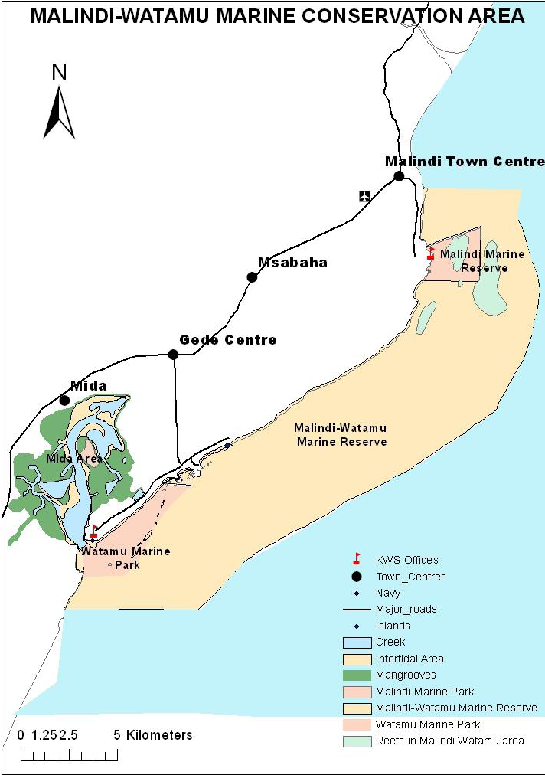
Despite the value of the goods and services provided by these ecosystems, coral reefs, mangrove forests and seagrass beds are all under increasing pressure. Human activities such as uncontrolled and destructive exploitation of resources, pollution and unplanned and/or poorly managed tourism and urban development are some of the threats facing these habitats. These impacts are projected to worsen as increased population growth leads to greater pressure on marine resources and climate change impacts (McClanahan et al., 2005).
The Watamu Demo Site is located on the Kenyan coast, approximately 120km north of Mombasa, within the Malindi District (Kilifi County) in the Coast Province of Kenya. The Watamu Demo Site extends 3.5 nautical miles seaward (according to the extent of the Kenya Wildlife Services (KWS) authority) and landward from Jacaranda Hotel to the end of Mida Creek mouth (border of Uyombo village). The Demo Site falls within the Watamu Marine Park and Reserve (also known as Watamu Marine Protected Area) and within the broader Malindi-Watamu Marine Conservation Area (See Figure 1).
Figure 1: Malindi-Watamu Conservation Area (KWS, 2013)

Baseline Study

Approach to the Development of the Baseline Report
As an initial step in the implementation of the Reef and Marine Recreation Management (RMRM) Thematic Area of the Collaborative Actions for Sustainable Tourism (COAST) Project in each of the three demonstration sites (Demo Site) countries, EcoAfrica set out to collate and analyse information that would help to guide and inform project activities throughout the project period. This information was collated into a Baseline Report for each Demo Site. Towards the end of the COAST Project, each Baseline Report was revised to incorporate information emerging during project implementation.

Structure and Function of the Baseline Report
This Baseline Report serves as a collation of existing information and stakeholder input. It should be noted that the information contained in this report was supplemented as the project implementation activities progressed. This section presents the methodology used to collect the information. Subsequent sections include the main findings emerging during project implementation and conclusions drawn during project closure.

Approach and Methodology
The development of this Baseline Report involved a literature review, two stakeholder surveys (the first was conducted in October 2011, the second in May 2014), meetings with project partners, local stakeholders and relevant experts, as well as information emerging from the ecosystem assessments, participatory mapping and awareness raising and training activities. In addition, a stakeholder map was developed for the Demo Site to illustrate some of the key stakeholders and their relationships. The Baseline Report also includes information emerging from the sustainability management planning process that led to the development of the key project output: “Watamu Marine Tourism Management Operational Strategy”. Finally, some of the key points highlighted during the UNIDO-led Participatory Result Reporting Tool (PRRT) workshop process held on 13th March, 2014.

Literature Review
A literature review was conducted on existing background information pertaining to the country and the Demo Site in particular in order to have a clear understanding of the project and to inform the design of appropriate benchmarks and indicators. Lists of some of the key documents used for literature review are included in the References section of this report. The literature review also included a review of the training needs assessment (TNA) developed for the Kenya Demo Site under the COAST Project, a process that resulted in the development of the “Training, Awareness Raising and Capacity Building Report” for Kenya Demo Site.

Stakeholder Surveys
To inform this Baseline Report, two stakeholder surveys were done. The first survey was conducted between 11th and 20th October 2011. The primary aim of the baseline survey was to record characteristics of and issues relating to the social economic status of the people in the area, to identify sensitive/damaged marine ecosystems (mangroves, seagrasses, sandy beaches and coral reef sites), and to determine the best way to communicate with local stakeholders in the RMRM Thematic Area of the COAST Project. A survey was developed to obtain current information from a sample of local stakeholders from the Demo Site area. A copy of the survey tool, a structured questionnaire, is provided in Annex 1. Annex 2 outlines the checklist for key informants. The structured questionnaire was used to capture information on priority livelihoods activities, damaged mangrove and reef sites, effectiveness of legislation and governing institutions, perceptions on and existing knowledge of the COAST Project, training undertaken, presence of charismatic species, popular reefs/marine recreational areas, education levels of the people, and identification of threatened reefs.
A total of 119 people were interviewed and the interviews were conducted with local stakeholders as well as relevant key informants from government partners, research organisations, NGO groups and the private sector. A total of 14 sites were visited for the survey. These included: Uyombo, Sita, Dabaso, Dongokundo, Watamu Beach, Watamu, Aquarius, Chafisi, Magagani, Timboni, Turtle Bay, Mapago, Kirepwe, and Jacaranda. The survey was composed of several categories including: community participation, awareness, trainings attended, livelihood, regulatory and institutional assessment, fishing, diving and tourism. The information collected was checked and supplemented during subsequent project implementation.
The second survey was conducted during May ending early June 2014. The primary aim of the follow-up stakeholder survey was to obtain feedback from key stakeholders who had been involved in the RMRM Thematic Area project activities as to their perceptions of the successes and failures of the project and to highlight key issues and opportunities that will remain after the project closes. The sample size of the survey was 17 respondents. A copy of the survey tool, a structured questionnaire, is provided in Annex 3. Interviews were conducted with local stakeholders, relevant key informants from government partners, NGO groups and the private sector.

Ecosystem Assessment and Mapping
The rapid ecosystem assessment and participatory mapping activities provided an indication of the key sensitive ecosystem areas and degraded or impacted sites. Reef surveys were conducted using rapid reef assessment approaches to obtain an understanding of the degree and type of reef usage, as well as the type of impacts from marine recreation. The rapid assessment approach using a combination of techniques such as: i) Photographic Profiling; ii) Fish and Coral Counts (hard and soft corals and other indicator species), iii) Photos along a Transect and iv) Video Transects. These were supplemented with existing research findings and stakeholder consultations. The assessment supported the identification of the sensitive marine areas within the overall Demo Site and the identification of some of the key current human impacts from resource use and tourism on the marine system.
The participatory mapping exercise was undertaken through ongoing consultation with stakeholders and field visits to identify key features, impacts, areas of concern, and opportunities for improved management. GPS points were recorded for major features, as possible, relating to the reef and marine recreational use. Collection of additional information through the ecosystem assessments, ‘ground-truthing’, existing research and stakeholder participation, contributed to the mapping exercise. Mapping of some of the major sensitive ecosystems (reefs, seagrass beds and mangroves) was supplemented by existing information.
The draft maps produced were discussed with the DSMC members, villagers in the Demo Site, researchers, lodge owners and other key users of the Bagamoyo Demo Site. Areas of specific use or concern identified by the stakeholders during the consultation meetings were also mapped. A second and final draft of the maps was presented to stakeholders for further feedback and input, which was incorporated into the final maps. The aim of the maps was to provide information to orientate management (sensitivities, degradation, threats, management arrangements and priorities, research and information gaps) of the site.

Training, Awareness Raising and Capacity Building
The approach to identifying training, awareness raising and capacity building needs was participatory, collaborative and iterative, involving local stakeholders within the Demo Site. This approach was also based on the outcomes of the Training Needs Assessment conducted by the COAST Project in 2010. Discussions were held with local stakeholders and workshop sessions conducted with the Demo Site Management Committee (DSMC) throughout the project period assisted in keeping interventions relevant and adapting to changing local needs. Training, awareness raising and capacity building applied in the Demo Site included:
- Participatory planning exercises with specific stakeholder groups;
- Compilation and implementation of tailor-made training courses;
- Awareness raising efforts amongst specific user groups; and
- Developing and distributing of a marine tourism documentary and other locally relevant information.

Specific training, awareness raising and capacity building activities undertaken during the project period included: i) ‘Sea through the Looking Glass Boat’ Training, specifically for boat operators; ii) Developing a Code of Conduct for Marine Tourism; iii) Geographical Information System (GIS) Training, specifically for DSMC members; and v) Reef Monitoring and Adaptive Management Training, specifically for Kenya Wildlife Service (KWS) rangers.

Stakeholder Map
A stakeholder map for the Bagamoyo Demo Site was developed to assist with the identification of relevant stakeholders for the RMRM Thematic Area. The stakeholder map is included in Annex 4 and illustrates the main stakeholders of the RMRM Thematic Area and their interrelationships.

Overview of the Coastal and Marine Areas

Description of the Area
The Watamu area hosts an exceptional wealth of biodiversity, which forms the basis of tourism and trade along this stretch of coast. The Watamu Marine Park covers an area of 10km² whereas the Reserve covers an area of 32km² in addition to a 100ft wide strip of coastal land above the high-water mark. It is well known for its pristine sandy beaches, rich marine biodiversity (including visiting whale sharks, manta rays and three species of sea turtle), and its reef-protected lagoon. The water is relatively shallow in the Demo Site apart from the area around the entrance to Mida Creek and a channel running along the length of the Marine Protected Area (MPA). Small coral patches (locally known as Coral Gardens) lying parallel to the shore are not exposed at low tide and are marked with buoys (KWS, 2013).
The Malindi/Watamu Marine Protected Areas (MPAs) host a complex diversity of fringing, patch and deep-water coral reefs with more than 60 coral genera represented. Coral families include Favidae, Poritidae and Acroporidae and the underwater flora comprises mainly Cymodocea algae. The Park also hosts numerous species of fish from more than 12 families. The Watamu Marine National Park was designated as a Biosphere Reserve in 1979. Mida Creek is a large creek lined with mangrove forests and renowned for its birdlife. Mida Creek features expanses of diverse seagrass beds and a highly productive mangrove habitat in which 9 mangrove species are recorded within an area of about 1,600 ha. The estuarine conditions of Mida Creek are maintained by groundwater seepage, with the adjoining Arabuko Sokoke Forest and Nature Reserve (42,000 ha) that forms the water catchment area (KWS, 2013).
While not part of the Watamu Demo Site for the COAST Project, the Arabuko-Sokoke Forest is worth mentioning as an essential protected ecosystem in the area. The Arabuko-Sokoke Forest covers 420km². It is one of the last remnant indigenous forests in Kenya, the largest and most intact coastal forest in East Africa, and by far the largest remnant of the forests that once dominated Kenya's coastal fringe. The forest plays a key part of the East African Coastal Forests Endemic Bird Area.
Coral reefs, mangrove forests and sea grass beds are however, all facing many threats from human activities including over-exploitation and destructive exploitation of living resources, pollution, sedimentation, unplanned tourism and urban development. It is projected that these impacts are likely to worsen in the future due to increased human population growth, leading to increased pressure on marine resources as well as climate change impacts such as bleaching of coral reefs (McClanahan et al. 2001). According to the initial stakeholder survey results, the main environmental concerns of respondents are: i) Beach encroachment; ii) Deforestation of the mangrove forests; iii) Increased populations; iv) Pollution from hotels; and v) Poor fishing methods.
In terms of mangrove damage, respondents in the initial stakeholder survey listed specific mangrove sites of Magagani, Kirepwe, Vigaeni, Uyombo and Chafisi as having a higher rate of degradation (see Figure 2).

Figure 2: Rate of Mangrove Damaged

The main type of damage to mangroves was cited as deforestation for firewood and poles for construction. Other threats to mangroves include environmental factors, removal for revenue and the use of poor fishing gear.

Respondents listed the most threatened reefs in the Demo Site as follows:
- Banco  - Barracuda  - Barazani  - Chafisi  - Coral Garden  - Darakasi  - Keani  - Kirepwe  - Kitangani  - Magagani  - Mawe ya Thumu | - Mayonda  - Mida creek  - Mida Majaoni  - Mlangoni  - Sudi Island  - Uyombo  - Watamu  - Watamu Banks  - Watamu Beach  - Watamu Marine Park

The reasons for reef damage are listed primarily as the use of poor fishing methods and environmental factors.

Socio-economic Overview of Watamu
The population of Watamu is approximately 9,000 inhabitants. The majority of the inhabitants are highly dependent on marine and coastal resources for their livelihood. Tourism is the key socio-economic activity in Watamu. The tourism industry is one of the primary employers for the local people and threats to its long-term sustainability are a serious concern to the residents and the government alike. The following section provides an outline of some of the key findings emerging from the initial stakeholder baseline survey.

Education Level
According to the survey results, only 11% of women interviewed attained a secondary level of education. The majority of the women who received education, attained primary level of education. Of the men interviewed, almost half, 44% had reached a primary level of education and 20% attained a secondary level of education. Less than 1% attained a tertiary level of education (see Figure 3 below).

Figure 3: Level of Education

Livelihood Strategies
According to the first baseline survey the top three livelihood activities in order of importance were agriculture (subsistence and commercial farming), entrepreneurship (small business, craftsmanship, palm wine production and firewood production and sales) and fishing (see Figure 4 below). Other activities included casual labour, and tourism.

Figure 4: Most Important Source of Livelihood

While not related to marine recreation, it is important to note that artisanal fishing is a critical socio-economic activity in the area that supports the livelihood of many of the local residents. This activity also supplies many of the restaurants and hotels in the area with fresh seafood. Controlled fishing using legal fishing gear is permitted in the Reserve area, but fishing within the more restricted Watamu Marine National Park (WMNP) “No Take” zone is prohibited due to the higher conservation status. Despite the importance of fishing, the income from tourism into WMNP is twice as high as income generated from fishing in nearby waters (Cowburn et al, 2013). Traditional fishing methods, although impacted by tourism development, are closely linked to the culture of the coastal communities in Watamu.
According to the initial survey, the majority of respondents preferred fishing line as the gear of choice. Basket traps and gill nets were the second and third choices of gear respectively. According to the survey, the majority of respondents avoid fishing between May and June due to their employment in other work and between June and July due to environmental factors including bad weather, high tides, strong currents and rough seas. In terms of facilities for artisanal fishing, there are no demarcated fish landing areas within the MWMCA area. Un-demarcated fish landing sites need to be mapped and gazetted to ensure continued access for the artisanal fishers. Conflicts sometimes arise between divers and fishermen when fishers moor their dhows on the dive moorings and catch the resident fish at the dive sites.

Preferred Method of Communication
In terms of stakeholder engagement for development initiatives and awareness raising, the respondents to the initial survey noted regular visits as the most appropriate method of communication including: visits at home, community meetings and field days. Information dissemination through media, newspaper and web sites was ranked as the second most important communication method, while use of opinion leaders was ranked as the least effective communication method.

Marine Tourism in the Watamu Demo Site
A variety of tourism-related activities take place within the Watamu Demo Site. The vast majority are directly linked to the coral reefs, mangroves and other sensitive marine environments. Tourism activities that are dependent on the beach and marine features include beach traders, glass bottom boat and dive operations, dolphin tours, sport fishing, snorkelling, wind/kite-surfing, sailing and boating. Water-skiing and other water sports are also available (see Table 1 below for activities that are undertaken in MPAs). Bird watching and mangrove walks are also offered in the Mida Creek area. Secondary activities include safari tour companies, entertainment spots and other service trades such as salons, boutiques, etc.
Table 1: Tourism and recreational activities within MPAs (after McClanahan, 2005)
Activities | Description
Glass bottom boat tours | Tourists and local residents hire glass bottom boats to visit the Coral Gardens reef Goggling is often done. A daily park fee is charged.
SCUBA diving | Tourists and locals are taken to the reef edge, wrecks, and caves for diving usually by companies affiliated with hotels. This activity requires daily park fees.
Goggling/ snorkelling | Visitors use goggles to either swim from the shore to the reef or from the glass bottom boats to the reef and are charged a daily fee.
Sailing | Modern and traditional sailboats are used either for tourist or fishing purposes. Sailing does not require a fee but anchoring in the MPA does.
Windsurfing/kite surfing | Tourists and locals can windsurf in MPAs without paying a fee.

The key socio-economic activity within Watamu is tourism, with numerous hotels, guesthouses and lodges (see Annex 5 for the list of guest accommodation), associated beach trade and boat tour operators to the Marine Reserve and Marine Park. The majority of tourists originate from Europe, and Italy in particular. The high-density of tourism development in Watamu has led to restricted public access to recreational beaches. Some beach access points have been blocked altogether while others have narrowed considerably due to encroachment. There are also several plots of fenced, but empty, beachfront land.
Respondents in the initial survey identified high seasons months (Table 5) and low seasons months (Table 6) for marine recreation activities. Respondents also listed the number of trips done for each activity (diving, snorkelling and other excursions).
Table 5: High season months for Marine Recreation Activities
Months | No of Trips Diving | No of trips Snorkelling | Other excursion
August to March | 40 | 33 | 68
September to March | 12 | 4 | 2

Table 6: Low season months for marine recreation activities
Months | No of Trips Diving | No of trips Snorkelling | Other Excursion
April to July | 27 | 26 | 38
May to June | 0 | 0 | 0

The tourism industry is one of the primary employers for the local people and threats to its long-term sustainability are a serious concern to the residents and the government alike. Ecotourism enterprises are growing in the area with community groups exploring the opportunities of sustainable tourism activities that can benefit both the environment and communities. There are currently 161 registered tour operators in both Malindi and Watamu (see Annex 6 for a list of tour operators). The majority of the owners are Kenyans, while the remainder are owned by Italians, Germans and Swedish citizens.
According to the initial survey results, areas that are most popular to tourists include: A Roche Kenya, Blue Lagoon, Blue Safaris, Coral Garden, Dabaso, Fungu Bomu, Fungu nyenga, Gede Museums Goggling Jacaranda, Kadaina, Kirepwe, Kitangani Magagani, Mapango, Marine park, Mida, Ocean Breeze, Saradenya, Sudi, Sun palm island, Uyombo, Wakawaka, Watamu, Whale Island. Table 7 lists the different locations for marine recreation according to activities while Table 8 lists the sites at which charismatic species are observed.
Table 7: Sites for Recreational Activities
Water sports | Game fishing | Day Visitors
Dabaso | Deep Sea | Dabaso
Sita | Ngomeni | Sita
Wakawaka | Malindi | Wakawaka
Kirepwe | Seliali | Kirepwe
Majaoni | Reeps | Majaoni
Sudi | Watamu Banks | Sudi
 |  | Mida Bird Hide

Table 8: Main Sites for Charismatic Species and Others
Dolphin | Sea Turtle | Sharks | Shell Collection | Octopus | Crab Fishing
Darakasi | Banco | Banco | Kadaina | Keani | Banco
Mlangoni | Twiga Hotel | Kenioni | Kaiwe ka ngamira | Kirepwe | Kadaina
Kirepwe | Kirepwe | Mawe ya thumu | Turtle Bay | Komiyoni | Mapago reef
Open Ocean | Thoga |  | Open Sea | Maweni | Majaoni
Komiyoni | Mashogo |  |  | Mawimbini | Komiyoni
Seliali | Mida creek |  |  | Open Ocean | Matsagoni
Watamu Beach | Mtu Nyumbani |  |  |  | Mida Creek
Mtu Nyumbani | Open Ocean |  |  |  | Sudi
 | Watamu Bank

The five most popular main dive sites in Watamu according to the respondents are North Kenya, Yellow Bay, Turtle Bay, Ngomeni, J Sharp, and Red Bull. Popular snorkelling sites are Coral Garden and Mida Creek. Table 9 below illustrates the current visitation rates to Watamu Marine Park between August 2012 and January 2013.
Table 9: Watamu Marine Park Visitors Data from August 2012-January 2013 (Source KWS Watamu)
Months | Aug 2012 | Sept 2012 | Oct 2012 | Nov2012 | Dec 2012 | Jan 2013
Adult Kenya Citizen | 599 | 463 | 352 | 709 | 1465 | 894
Child Kenya Citizen | 204 | 32 | 173 | 28 | 296 | 177
Adult Resident | 275 | 123 | 371 | 260 | 709 | 498
Child Resident | 2005 | 1915 | 201 | 47 | 217 | 126
Adult Non Resident | 250 | 111 | 1725 | 2186 | 3006 | 4414
Child non Resident | 3456 | 2740 | 102 | 135 | 417 | 424
Total/month | 3456 | 2740 | 2924 | 3365 | 6110 | 6533
Boat with Pass | 238 | 176 | 241 | 290 | 497 | 349
Boat without pass | 32 | 39 | 31 | 42 | 101 | 173

Three private SCUBA diving operators (Oceans Sport Resort, Blue Fin Diving and Turtle Bay Hotel) operate within the Demo Site. Local safari tours (inclusive of snorkelling) are offered by the hotels and private operators to the marine park. Presently the Watamu Demo Site has Codes of Conduct (CoC) for dolphin watching, snorkelling and tourism. Some reef monitoring is done by Coastal Ocean Research Development in the Indian Ocean (CORDIO), the Wildlife Conservation Society (WCS) and KWS. While the linkages between marine tourism and the local economy could be much improved in the Demo Site area, local marine tourism enterprises are prevalent in the area, with increasing interest by local residents in the opportunities of marine tourism activities.
Figure 5 illustrates the natural features, as well as the diversity of tourism activities in the Watamu Demo Site, illustrating that marine tourism-related activities depend on the beach and marine features. Figure 6 illustrates the higher use zone and some of the key sensitive marine areas impacted by tourism including coral reefs, mangrove forests, seagrass beds and sandy beaches. The maps provides a useful illustration of the location of sensitive ecosystems and their proximity to high tourism use (the area from Kanani, all along the coastline to Uyombo). It is evident that the higher use and impacted areas relate directly to the level of access by users of the areas and the need for improved management in these areas.

Figure 5: Marine Recreation Activities within the Watamu Demo Site

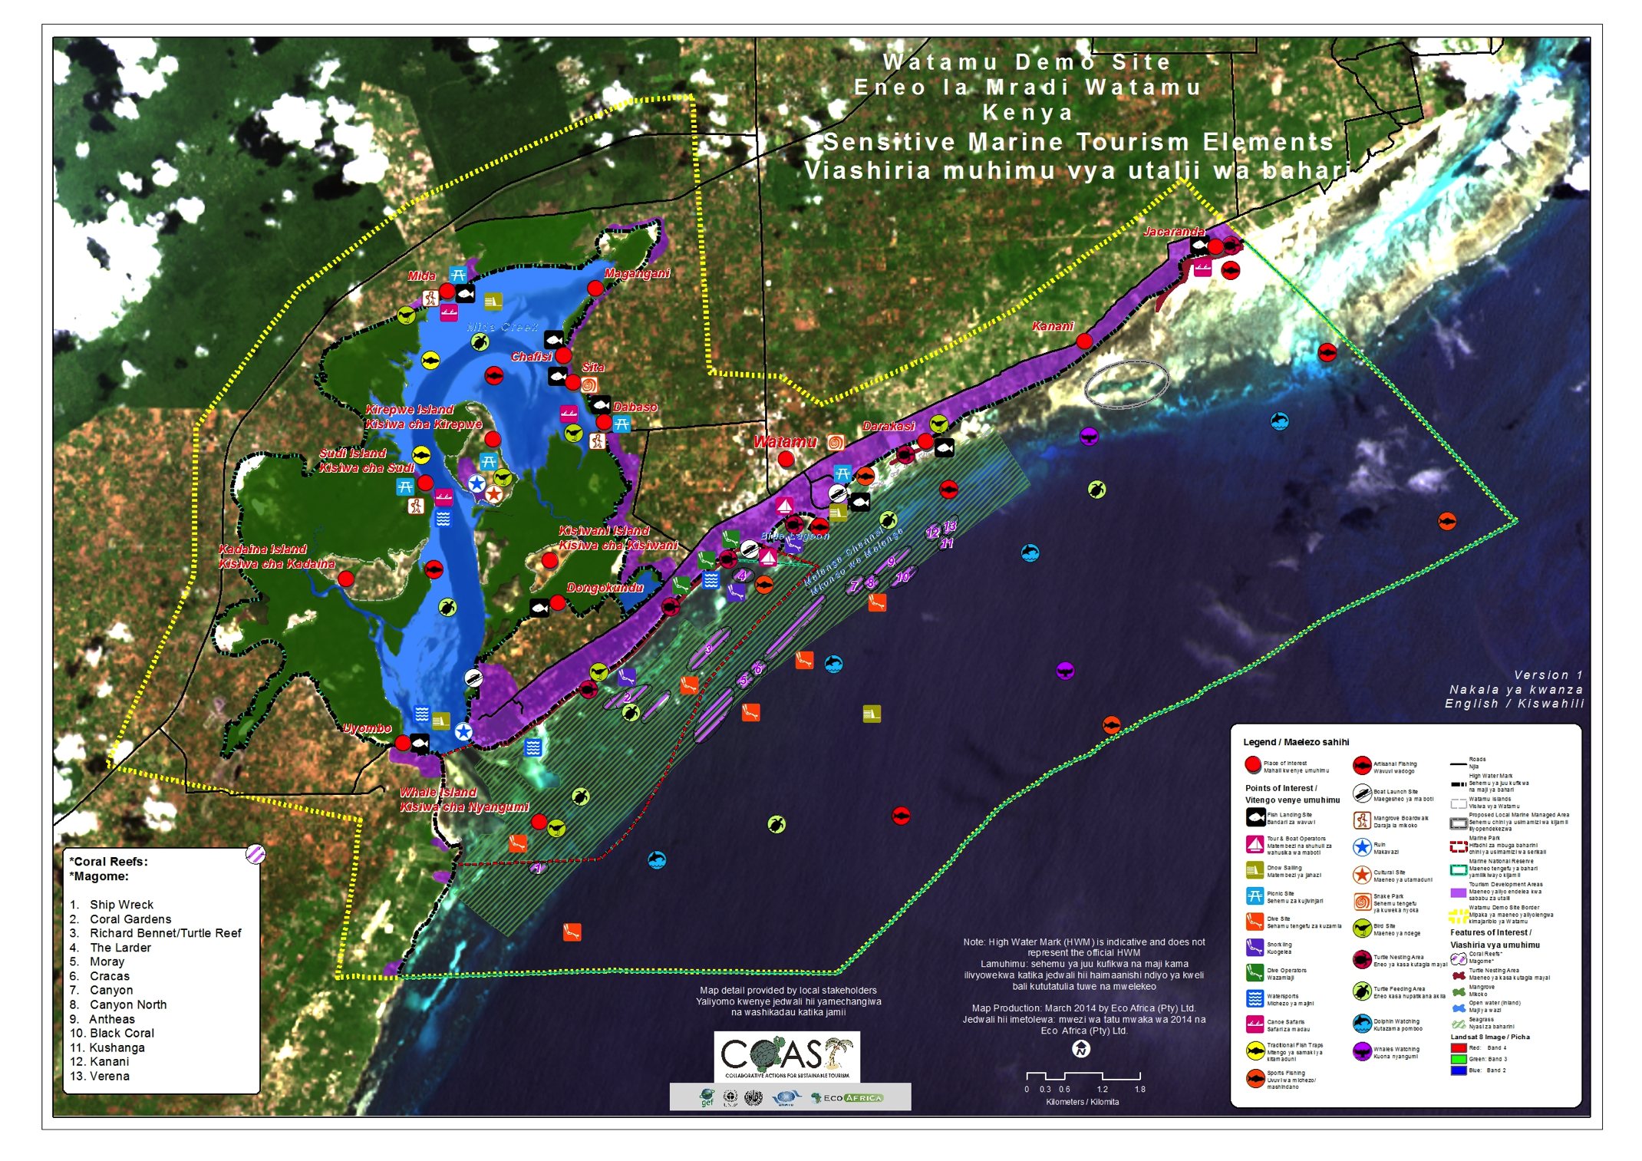

Figure 6: Marine Tourism Impacted Sites within the Watamu Demo Site
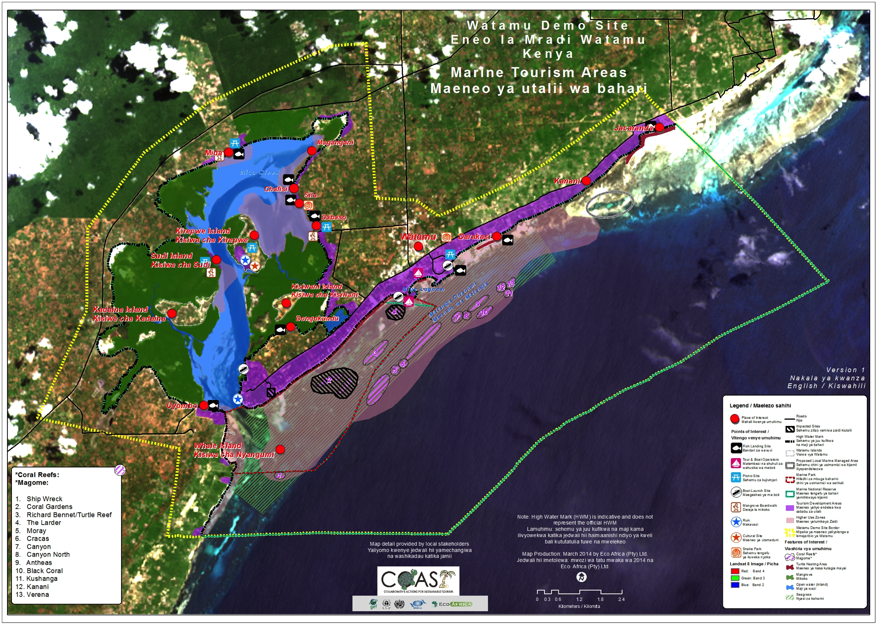

Current Marine Tourism Management Measures

Kenya was the first country in Africa to established a marine protected area and since the late 1960s has declared a number of marine parks and reserves along its coast (See Table 2 below). Fishing is prohibited in the Parks, and only traditional methods of hand-lines and traps are permitted in the Reserves.
Table 2: List of MPAs along the Kenyan coastline (GOK/MOTW 2007).
Site name | Designation | Year established | Size (km²)
Kiunga | Marine National Reserve, Biosphere Reserve | 1979 | 600
Malindi-Watamu Marine National Park | Marine National Park, Biosphere Reserve | 1968 | 16.3
Malindi-Watamu Marine National Reserve | Marine National Reserve, Biosphere Reserve | 1968 | 245
Mombasa | Marine National Park | 1986 | 10
Mombasa | Marine National Reserve | 1986 | 200
Kisite | Marine National Park | 1978 | 28
Mpunguti | Marine National Reserve | 1978 | 11
Diani | Marine National Reserve | 1993 | 75

The Watamu Demo Site falls within the Malindi-Watamu Marine Conservation Area that incorporated a complex of protected areas including the Watamu Marine National Park (WMNP) and Watamu Marine National Reserve (WMNR), Malindi Marine National Park (MMNP) and the Malindi National Reserve (MNR) as core areas, as well as a buffer zone of 500 meters that extends from the high water mark towards the inland and towards the deep sea around the MPAs.
The Demo Site is therefore covered by the management plan for this complex of protected areas. The Watamu and Malindi Marine National Parks were established in 1968. These were the first MPAs in Africa and are primarily designed to conserve Kenya's coral reefs. The larger protected areas also enclose important breeding sites for migratory marine birds, marine mammals and turtles. In recognition of the unique wildlife biodiversity of the area, the two Watamu and Malindi Marine National Reserves and the Watamu and Malindi Marine National Parks were declared Biosphere Reserves under the Man and Biosphere Reserve Programme of UNESCO. The Biosphere Reserve area is located at 03°14' to 03°25'S; 39°57' to 40°11'E and covers a total area of 19,600 ha (KWS, 2013).

Overview of Governance of Coastal and Marine Resources

Institutional Framework
A number of government agencies at different levels have jurisdiction over governing marine and coastal resources. The challenges and issues encountered in managing marine and coastal resources are multi-sectoral and therefore cut across various agencies. The sectors that have a direct impact on the marine and coastal environment include: maritime sector; fisheries sector; environment sector, wildlife sector; forestry sector; water sector; energy sector; agriculture sector; mining sector; and the tourism Sector. At the national level, the Coast Development Authority (CDA) has the responsibility of planning and integrating coastal development activities (McClanahan et al., 2005).
The authority for management of Marine Parks and Reserves is vested with the KWS. According to the Policy Framework that led to the establishment of the KWS, the general goals of organization are the: i) conservation of natural environments of Kenya, for the benefit of Kenyans and as a world heritage; and ii) sustainable management of wildlife resources; and iii) protection of people and property from injury or damage from wildlife (McClanahan et al., 2005).
Adjacent marine areas fall under the jurisdiction of either the Fisheries Department or the Forestry Department depending on the ecosystem and the extractive activities. Municipal councils are usually responsible for administering the adjacent terrestrial areas. KWS currently falls under the Ministry of Environment and Natural Resources. The Fisheries Department licenses all fishing activities in the Marine Reserves. The first establishment of MPAs caused disagreement between the KWS and the Fisheries Department, due to conflicting mandates on coastal zones with one agency primarily mandated for conservation and the other for increased exploitation. The problem also still exists whereby artisanal fishers believe that the protected areas were exclusively created for the tourism industry, as fishers are not allowed to fish in the parks (KEMFRI, 2011).
The location of the Kenya Marine and Fisheries Research Institution (KMFRI) and the Kenya’s Fisheries Department (KFD) in different government ministries and infrequent collaboration, created episodes of confliction (McClanahan et al., 2005). Recent development of a Memorandum of Understanding (MOU) between the two institutions aimed to clarify their mandates and create a basis for sharing authority and management. Table 2 below lists the different government departments with jurisdiction over marine and coastal resources.
Table 3: Institutional arrangements for coastal management (after KEMFRI, 2007)
Department | Ministry | Department Role/Responsibility
Kenya Wildlife Service | Environment and Natural Resources | Management and conservation of wildlife focusing on protected areas and endangered species
Coast Development Authority | Agriculture and Rural Development | Promote sustainable coastal development and economic exploitation of coastal and marine resources
Fisheries Department | Agriculture and Rural Development | Management and development of fishing resources, licensing, regulation of gear, promotion of aquaculture
Forestry Department | Environment and Natural Resources | Management of forests (coastal and mangrove) including licensing of logging and reforestation
Kenya Marine & Fisheries Research Institute | Ministry of Agriculture | Research into all aspects of aquatic systems including physical and social sciences
Kenya Maritime Authority | Ministry of Transport and Infrastructure | Management of maritime vessel standards; registration of ships; navigation and maritime training management
Kenya Ports Authority | Ministry of Transport | Management of ports
National Environment Management Authority | Ministry of Environment | Environmental management
Municipal councils | Local Government | Regulation, licensing and management of city activities
Provincial and District Administration | Office of the President | Liaison with central government on all development activities at the grassroots
Tourism Department | Ministry of Tourism | Management and regulation of all tourism activities
Tourism Finance Corporation | Ministry of Finance | Financing domestic tourism development. Previously Kenya Tourism Development Cooperation (KTDC)
Survey Department | Ministry of Lands | Mapping the boundaries of the maritime zone

Additional stakeholders involved in marine and coastal management in Watamu include the local NGOs and Community Based Organizations (CBOs). Table 3 below lists these organizations and outlines their role.
Table 4: Role of NGOs and CBOs in Marine and Coastal Management
Institution | Role
A Rocha Kenya | Research and conservation of birds and more recently, marine ecosystems and experience in ecotourism development
Community-based Environmental Conservation (COBEC) | Providing capacity and support to community environmental and conservation initiatives
Local Ocean Trust | Provide education awareness and conservation of sea turtles
Mida Creek Conservation Committee (MCCC) | Umbrella organization coordinating mangrove conservation and community ecotourism in the Mida Creek Reserve
Nature Kenya | Training for ecotourism development
Watamu Association of Boat Operators (WABO) | Umbrella organization representing beach operators that take tourists on boat excursions to Coral Gardens
Watamu Marine Association (WMA) | Umbrella organization with coordination, communication and facilitation capacity and linkages to all relevant stakeholders
Watamu Safari Sellers Association (WSSA) | Network of tour and safari sellers promoting ecotourism

The Watamu Demo Site falls primarily within the WMCA and is therefore largely under the mandate of the KWS. However, management of this area remains challenging. The KEMFRI, CDA, WMA, NEMA and other agencies also play a role in the management in the area, but greater coordination is needed. For example the KWS mandate for the area commences from the high-water mark, including the 30m riparian zone whilst the NEMA’s mandate commences from 60m from the high-water mark. Further complicating the management of the area is the lack of a zonation and development plan for Watamu and existing systems are not adequately enforced. For example the Beach Management Plan (BMP) exists for the area but is not implemented.

Legislative & Regulatory Tools
Kenya has an array of national environmental legislation (see Table 4 below) that has created overlapping and conflicting mandates for managing marine and coastal issues. Much of the legislation is old and no longer sufficient to manage current pressures. Marine and coastal ecosystems have continued to degrade, even within protected areas. While the Tourism Policy and Law recognize the value of Kenya’s biodiversity and that tourism is nature-based, and that there is a need to ensure proper management of the environment and resource base for sustainable development, they still need to embrace ecosystem-based management and provide for multi-sectoral conflict management (KEMFRI 2007).
Specific MPAs are established under the Wildlife Conservation and Management Act of 1976. Although MPAs are governed under this Act, the regulations apply to protected areas in general and are not specific to marine areas. The KWS has therefore, developed specific regulations for MPAs. For example a 10-year (2011-2021) management plan for the Malindi/Watamu Marine Conservation Area (MWMCA) has been drafted following a highly participatory stakeholder consultation process. This Management Plan, currently in draft form, was formulated to ensure that the economic health of MWMCA is preserved and the area is sustainably used (KWS, 2013 doc).
Since the Malindi and Watamu MPAs are geographically and ecologically connected, and since the MPAs are managed primarily by KWS in collaboration with stakeholders, it was agreed that a single conservation area management plan titled the Malindi-Watamu Marine Conservation Area Management Plan would suffice. According to the draft MWMCA Management Plan, this document was formulated in line with the KWS Protected Area Planning Framework (PAPF) and provides a detailed methodology for the entire planning process ensuring that all management plans are developed according to a standardized process and having a similar structure (KWS, 2013).
The Environmental Management and Coordination Act (EMCA) 1999, is relevant to MCA and MPA implementation as it establishes an overarching legal and institutional framework for the management of Kenya's environment. The Act recognizes the coastal zone for planning and development purposes and imposes severe penalties for land-based marine pollution. While the Act recognizes institutions with mandates for marine and coastal resources management, the institutional framework for the National Environmental Management Authority (NEMA), has yet to be fully effective.
Table 5: Key Policies and Laws Relating to Marine and Coastal Protection
Policy or Law | Relevance
Wildlife Conservation and Management Act 1976 | Establishment of MPAs
Maritime Zones Act 1989 (MZA) | Consolidates the laws relating to the territorial waters
Coast Development Authority Act 1990 | Establishes an Authority to oversee and plan the implementation of coastal and Exclusive Economic Zone development projects
Fisheries Act 1991 | Development, management, exploitation, utilization and conservation of fisheries resources
Integrated Coastal Zone Management Policy | Integrated planning and coordination of coastal development. Nested in the MZA and the EMCA
Physical Planning Act 1996 | Governs all land use and planning, especially in urban centres
Environmental Management and Coordination Act (EMCA) 1999 | Legal and institutional framework for environmental management
National Environmental Action Plan (NEAP) 1999 | Overarching National environmental policy, approved in 1999
National Biodiversity Strategy and Action Plan (NBSAP) 2002 | National framework of action for the implementation of the Convention on Biological Diversity
Water Act 2002 | Empowers the Minister to formally protect river catchments
Local Government Act 2009 | Regulates local authorities on waste management and treatment

Needs for Strengthening the Legal Framework
According to the initial stakeholder survey, the vast majority of interviewees believe that the majority of marine and coastal user groups comply weakly with the law within the Demo Site. The following institutions were listed being responsible for management of marine resources:
- Kenya Wildlife Service (KWS),
- Kenya Marine Fisheries Research Institute (KMFRI),
- Kenya Forest Service (KFS),
- Fisheries Department,
- National Environment Management Authority,
- Tourist Police,
- National Museums of Kenya,
- Coast Development Authority (CDA), and
- Kenya Maritime Authority (KMA).
The most effective institution according to the majority of respondents is KWS, followed by KFS. The main challenges to effective management were listed by participants as a lack of involvement of women in fish trading, the need for community collaboration and participation of local stakeholders in law formation and the lack of suitability of laws to meet everyone’s needs.
According to respondents in the second stakeholder survey, the following were listed as priority actions to improve management of reef and marine recreation in the Demo Site:
- Capacity building and regular training;
- Regulated tourism activities and law enforcement;
- Zone sensitive areas and creation of a beach management plan
- Education and awareness creation of the value of healthy marine ecosystems;
- Alternative livelihood support;
- Promote sustainable tourism;
- Empower KWS to do their work i.e. survaillance of the marine park;
- Mapping of sensitive areas
- Sewage treatment;
- Research and regular and focussed M&E;
- Integrate all stakeholders, especially hotels and less organised stakeholder groups; and
- Development of grass-roots structures of governance.

Results from the Research

Some of the results emerging from the RMRM project activities including the ecosystem assessment, mapping and stakeholder consultation are outlined below.
Some of the results emerging from this study demonstrate that presently there are signs of damage and stress being experienced within the reef and marine ecosystem. At the moment physical damage, bleaching and nutrification of reefs from land-based sources of pollution are evident in some areas has having extreme impacts. Also evident within the Demo Site is anchorage damage, which can be seen to some near shore reef areas due to unmanaged boat mooring. Within the Mida Creek area, the presence of mangrove deforestation is evident. Existing research and user perception suggests a decrease in species and a decline in the health of the reefs and associated ecosystems. Negative impacts from a number of possible factors such as fishing, pollution, coral bleaching, physical damage from visitors, natural impacts (storm events, nutrient loading through rivers, siltation, etc.) can be contributing to decrease in species numbers and diversity.
Some of the results emerging from the ecosystem assessment, mapping, stakeholder consultation and literature review are as follows:
- Clear evidence exists of ecosystem change and degradation in some of the higher-use areas from tourism activities. This includes breakage of corals as a result of visitation, disturbance of turtle nesting areas on the beach areas from unregulated and poorly planned development and conflicting use activities. This further threatens the nesting areas of the endangered marine turtles and increases the risk of disturbing or destroying countless other species.
- Risk to critical nursery and feeding areas within the Demo Site from inappropriate and uncontrolled activities such as heavy visitor traffic, feeding of fish, disturbance to marine organisms (i.e. removal or moving of organisms), trampling of corals and degradation of mangrove forests.
- Minor evidence of coral recovery following the 1997/8 coral bleaching event.
- Marine pollution from multiple land-based sources in the coastal zone due to poor development and inadequate waste management.
- The need for strengthening capacity (financial capability, infrastructure and staff numbers and skills) for marine monitoring, control and surveillance to mitigate against poaching and piracy and to enforce wildlife protection and integrated ecosystem-based management.

Information of high-risk marine recreation areas and activities, as well as procedures to follow when injuries or mortalities occur, does not seem readily accessible. Safety of people participating in marine recreation activities is a growing concern and an issue that needs to be improved through stronger protocols and precautionary regulations, as well as greater awareness of the risks and options to reduce them.

Conclusions
The marine environment of the Watamu Demo Site represents an area of global significance, environmentally, culturally and economically. This site is home to important and endangered fauna and flora species and an array of other marine and coastal organisms and sensitive coastal ecosystems. The complex and interconnected ecosystems, the coral reefs, mangroves, seagrass beds and sandy beaches, support a highly productive web of organisms that provide an essential resource base for the local economy of the area. The health of the reef and marine environment of the Watamu area is under pressure from numerous and diverse human impacts, many of which are associated with the tourism industry and tourism use.
The high levels of poverty among populations living within the Demo Site result in the direct dependence of the majority of local communities on the marine resources for livelihood. The benefits of marine tourism have yet to contribute sufficiently to the lives of local communities. The nexus between unsustainable tourism practices, overutilization and destructive methods of the natural resource use and the need for stronger and more collaborative management and higher levels of awareness of the value of the marine environment, is resulting in a steady decline in the integrity and productivity of the natural resource base. This is impacting negatively on the tourism sector and more significantly, on the social and economic well-being of coastal communities in the Demo Site and in surrounding areas.
It is clear that collaborative action is needed among all sectors and user groups to recognise the complexities inherent in managing multiple user groups in a dynamic and diverse area and to prevent further degradation of the marine and coastal resource base. Fishers should definitely be involved in tourism projects, since the local economy and natural resource base are integrally linked. The local economy, development thereof and who receives the benefits needs to continue to be a primary consideration in terms of the management of negative impact from marine tourism.
Steps towards improving reef and marine management have been detailed in the sustainability management document entitled “Watamu Marine Tourism Management operational Strategy”, Version 1, the ultimate outcome of the RMRM activities in the COAST Project and compiled in collaboration with local stakeholders in the Demo Site.

References
Coastal Ocean Research Development in the Indian Ocean (CORDIO). 2009. Coral Reef Resilience Assessments in Malindi and Watamu Marine Parks and Reserve. Unpublished Report.

Cowburn, B., Smith, J., Sluka, R.D., Mohammed M.O.S.M., 2013. Impact of snorkeling on marine habitats and tourism industry of Watamu Marine National Park. A Rocha Kenya Occasional Research Report No. 26.

EcoAfrica Environmental Consultants. 2014. Training, Awareness Raising and Capacity Building Report Watamu Demo Site – Kenya. Report for the COAST Project.

Government of Kenya. 2008. Kenya State of the Coast Report: towards the integrated management of Kenya’s coastal and marine resources. UNEP and NEMA, Nairobi. 88pp.

ICRAN. 2004. International Coral Reef Action Network: Malindi Watamu MPA complex demonstration site project. Unpublished report.

Kenya Marine Fisheries Research Institution (KEMFRI), 2011. Policy and governance assessment of coastal and marine resource sectors in Kenya in the framework of large marine ecosystems. Report for the ASCLME.

Kenya Wildlife Service (KWS), 2013. Draft Management Plan for the Malindi/Watamu Marine Conservation Area (MWMCA) (2011-2021).

McClanahan, T. R. 2001. The recent ecological history and condition of the Malindi- Watamu reef complex. CRCP report. 31pp

McClanahan T. R., Mwaguni S., Muthiga N. A. 2005. Management of the Kenyan coast. Ocean and Coastal Management 48: 901-931.

Muthiga, N. and Weru, S. 2002. Status and Management of Marine protected Areas in Kenya: A case study of the Malindi-Watamu MPA complex. KWS report.

Annex 1: COAST Baseline Survey for RMRM
Date: __________________
Name of the Demonstration Site ______________ Country _________________
Name of Respondent _________________ Name of the interviewer

SECTION A: PERSONAL PARTICULARS
A1. Age ________________
A2. Gender
(1) Male…… (2) Female………
A3. Highest education attained
(1) Primary education (2) Secondary education (3) Tertiary education
(4) Informal education (5) none of the above
A4. How long have you been living/working here (years)?
(1) Less than 5 years (2) 5 - 10 (3) 11-15 (3) 15-20 (4) more than 20 years

SECTION B: AWARENESS OF COAST PROJECT
B1. Have you heard about the COAST project prior to this survey?
(1) Yes (2) No (if no, please jump to question B5)
B2. If yes, where have you heard about COAST project? Tick all that applies
Source | Response
Project team
TV
Newspaper
Radio
Other 1 (Specify)
Other 2 (Specify)

B3. If yes, what do you think is the main activity undertaken by the COAST project?
B3. Have you had any contact or communication with COAST project in the last 3 years?
(1) Yes (2) No
B4. If yes, what type of contact or communication have you had (don’t read list) (multiple responses)

Type of communication/contact | Response
attending a training or field day organized by the COAST project
attending a training or field day that another organization was running
a COAST project staff member visited my working place
attending a meeting organized by the COAST project
applying for funding from the COAST project
Other (Specify)

B5. COAST project has been developed to; demonstrate best practices and strategies to reduce the degradation of marine and coastal environments and to enhance sustainable tourism practices. If they wanted to communicate information to people in your area, what do you think would be the best way for them to do this? (Read list) (Multiple responses)
Best Way | Response
Don’t know
Visit people at their homes or properties
Have a field day
Put information in the local newspaper
Hold community meetings
Put information on the radio
Post information through the mail
Place information on their website
Email information
Place TV advertisements
Letterbox
Other (Specify)

SECTION C: LIVELIHOOD ACTIVITIES
C1. What are the livelihood activities that you depend on (tick all applicable livelihood activities, and rank the top most 3 in order of importance)
Livelihood activities | Tick all that applies | Rank the most 3 important activities (1=most important, 2=second most, 3=third)
Fishing
Agriculture
Tourism (tour guide, boat operator etc.)
Livestock keeping
Seaweed farming
Beekeeping
Fish vending (fresh, fried, sundried, salted…)
Food vending (mama lishe, food kiosks…)
Firewood/charcoal making
Small-business (shops/pharmacy….)
Craftsmanship (boat making, carpenter, mason, plumber)
Lumbering (timber and poles)
Tailoring
Employment (with formal monthly salary)
Casual labourer (in farms, building, factories etc.)
Other 1(specify)
Other 2 (specify)

SECTION D: COMMUNITY PARTICIPATION AND EMPOWERMENT
D1. Are you a member of local any organizations/associations? | 1=Yes
 | 2=No

D2. If yes, tick all organizations that applies | 1. Village Community Bank
 | 2. Women association
 | 3. Fishers association
 | 4. Farmers association
 | 5. Environmental
 | 6. Tourism association
 | 7. Others (specify)

D3. Have you ever attended training workshop/seminar? | 1=Yes
 | 2=No

D4. If yes, tick all training/ | 1. Health
workshop/seminar attended | 2. Environmental management
 | 3. Entrepreneurship
 | 4. Sustainable Fishing
 | 5. Sustainable Tourism
 | 6. Sustainable agriculture
 | 7. Others (specify)

SECTION E: REGULATORY AND INSTITUTIONAL FRAMEWORK
E1. Do you believe that the reef and associated resources are managed effectively?
(1) Yes (2) No

E2. List the main challenges in managing the reef and associated resources effectively?
E3 (a). Are there any government laws or local by-laws for management of the reef or mangrove or the activities that take place on or around the reef (i.e. laws for fishing or tourism)?
(1) Yes (2) No
(b). If yes, please list them
(c). If yes, how well do the people using the reef for fishing or tourism or any other activity, comply with the laws and regulations?
(1) Strongly comply (2) Weakly complied (3) Not at all
(d) Do you think the laws should be changed to improve management of the reef?
(1) Yes (2) No
Please explain
E4. (a) Do you know any government institution/s that are responsible for management of the reef and marine resources?
(1) Yes (2) No
(b) If yes, List them
E5. If yes, on a scale of 1 to 3, how effective do you think the government institution/s are in managing the reef and the activities taking place around the reef/mangroves? (1 being very effective, 2 being somewhat effective but needs improvement and 3 being Ineffective)
Name of the government institution | Effectiveness (1 to 3)

E6. (a) Are there any traditional management approaches followed on reefs/mangroves in your area?
(1) Yes (2) No
(b) If yes, list them!
(c) If yes, list the challenges that fishers/community have in carrying out their traditional management approaches
E7. (a) Are there any kind of co-management that exists between government and coastal communities for managing the reef or the mangroves (or other resources)?
(1) Yes (2) No
(b) If yes, what are they, please explain!
E8. What do you think should be done to improve management of the reefs in terms of strengthening the regulatory and institutional frameworks? Explain!

SECTION F: FISHERS (FOR MAPPING OF SENSITIVE AND DAMAGED AREAS)
F1. What are the most common fishing methods you use? (If many, mention at most 3 and prioritize them)
F2. What are the 5 most common fish species you catch?
F3. What is the trend of the fish catch?
(1) Increasing (2) Decreasing
Explain the reason
F4. How many hours, days and month do you fish per year (Fill in the table as appropriate)

Fishing Season | Number of months per fishing season | Average number of days per fishing month(s) | No of hours spent at sea per outing | Total (to be calculated after interview)
High fishing season
Low fishing season
Total number of hours per year

F5. Are there any months you do not fish at all?
(1) Yes (2) No
F6. If yes, name them and the reason for not fishing
Months’ name | Reason for not fishing

F7. Name the best 3 areas for fishing (Indicate on the base map provided)
Fishing area | Location/local name during good weather | Location/local name during bad weather
Coral Reefs | 1.  2.  3. | 1.  2.  3.
Sea grasses | 1.  2.  3. | 1.  2.  3.
Mangroves | 1.  2.  3. | 1.  2.  3.

F8. What are the factors that influence these habitats (positively or negatively) and what are the benefits for people from these habitats?
Habitat/resource | Influence on habitat from surrounding? | People’s benefit from these habitats/resource?
Coral reefs
Mangroves
Sea grasses

F9. According to your understanding, name and point out the five reefs that have been mostly damaged? And the reason why? (Tick if fairly or strongly damaged) Indicate on the base map
SN | Name of the reef | Strongly damaged | Fairly damaged | Reason for the damage
1.
2.

F10. According to your understanding, name and point out the five mangrove areas that have been mostly damaged? And the reason why? (Tick if fairly or strongly damaged) Indicate on the base map
SN | Name of the mangrove area | Strongly damaged | Fairly damaged | Reason for the damage
1.
2.

F11. Can you please indicate the fish aggregation sites in the map provided? (Indicate for which fish species)
SN | Local name of the fish aggregation sites | Type of species that aggregate
1.
2.

F12. Point out on the base map where you see charismatic marine species and other important fishing areas as listed below.
Marine species | Present (point on map) | Not present in this area
Dugong
Sea turtles
Dolphins
Sharks
Octopus fishing area
Shell collection area
Crab fishing area

SECTION G: DIVE CENTRES/TOUR OPERATORS (FOR MAPPING OF SENSITIVE AREAS)
G1. How many diving/snorkelling or excursion trips do you make in a season or a particular period of time?
Season | When (months) | Number of trips/month
High season |  | Diving:  Snorkelling:  Other excursion:
Low season |  | Diving:  Snorkelling:  Other excursion:

G2. Estimate the number of people (in approximation) with which you have arranged the following activities over the last year, and indicate on the map where the activities were undertaken:
Activities | Number of people in the last year | Where are the main sites for these activities? (names/type of sites and indicate their locations in the map provided)
snorkelling |  | S1.  S2.  S3.
diving |  | D1.  D2.  D3.
game fishing |  | GF1.  GF2.  GF3.
water sports |  | WS1.  WS2.  WS3.
day visitors |  | DV1.  DV2.  DV3.
other (specify) |  | 1.  2.

G3. Please list names for the three coral reef areas that appear to be most popular amongst dive/snorkel organizers and explain why they are popular (indicate in the map provided)
Site | Reason for popularity
a)
b)
c)
d)

G4. Please indicate whether you observe the incidences of the following (Tick all that applies) and point out where on the map.
Incidence | Response
Remains of fishing gear
Coral bleaching
Broken coral
Rubbish in the water
Rubbish on the beach
Oil in the water
Crown of thorns starfish
Dynamite fishing
Any other observation? Please describe

G5. Which reef areas (name three) do you think are most threatened? Indicate them in the map provided
G6. Are there any other marine/coastal areas that are popular among tourists (mangrove areas, sand banks etc.)? Please name them and point out on the map.
G7. Please specify what you think are the most pressing environmental concerns in marine waters in your area/dive sites
G8. What do you think needs to be done to improve management of the reefs?

THANK YOU FOR YOUR TIME AND COOPERATION

Annex 2: Checklists For Key Informants
(For input to regulatory and institutional assessment and for mapping of reef sensitive and damaged areas. A copy of the base map is needed)

Introduction questions for all key informants;

- What is your name?
- Where do you work?
- Do you have a contact number?
- Do you have an email address?
- What is your role in terms of managing the marine and coastal recourses (reefs/mangroves etc.)?

DISTRICT FISHERIES OFFICERS / DISTRICT NATURAL RESOURCE OFFICERS

- How many fish landing sites do you have in this district (Please, locate them in the map provided)
- How many types (mention them) and number of fishers, vessels, and gears were recorded in this district (according to the last census).
  - Fishers:
  - Vessels:
  - Gears:
- What are the most commonly landed fish species (types and quantities) in this area for the last fisheries catch assessment survey?
- Mention and indicate the number of fish processing facilities in this area.
- What are the different types of fishing methods practiced in different fishing grounds (e.g. coral reef fishery, mangrove fishery, sea grass fishery, intertidal fishery, open water/deep sea fishery) in this area?
- Are there any destructive fishing methods/practices in your area? If yes, what are they and where are they being practiced (indicate on the map)?
- Indicate fish aggregation sites in the map provided (and indicate for which fish species)
- Describe the different aquaculture (include bee keeping, crab fattening, fish farms, prawn farms etc.) in your area, in terms of:
- What is cultured?
- Where do they culture (indicate in the map provided)
- Its profitability to the coastal communities
- Mention and locate (in the map provided) the main land-based activities undertaken in your area (farming (what?), factories, forestry, etc.)
- Which land-based activities have major marine environmental impacts to your area?
- Provide information (in the map) on location of rivers, and dumping points and describe the type of discharged material (wastes)
- Are there any cases of sea-based sources of marine pollution (include the operational and accidental discharges from tankers and other shipping vessels as well as the fishing fleet)? Explain and try to point out on the map where?
- Can you recall any incidence of the occurrence of natural threats such as storms or floods in your area? Explain briefly, where / when the incidence occurred and what the impact was.

TOURISM OFFICERS

- How many tourist hotels/guesthouses do you have in this area?
- Indicate where and name them (locate on the base map)
- Indicate the capacity for each in terms of number of beds
- Also indicate the number of tourists/guests for each season (low and high) per year (% occupancy)
- Indicate the types, numbers and location (in the map) of the dive centres and tour operators in this area.
- Can you estimate the number of beach walkers/sun bathers per season (high - when and low - when) in your area of work
- Do you have mangrove nature trail sites (if yes, indicate their location in the map)

REGULATORY AND INSTITUTIONAL FRAMEWORK
- Do you believe that the reef and associated resources are managed effectively?
- What do you believe are the main challenges in managing the reef effectively?
- Are there any government laws or local by-laws for management of the reef or the activities that take place on or around the reef (i.e. laws for fishing or tourism)?
  - If yes, please list them.
  - How well do the people using the reef for fishing or tourism or any other activity, comply with the laws and regulations?
  - Do you think the laws should be changed to improve management of the reef?
- Which government institution/s are responsible for management of the reef and marine resources?
- How effective do you think the government institution/s are in managing the reef and the activities taking place around the reef?
- Do any of the fishers follow a traditional management approach when using the reef (i.e. closed areas/seasons or restrictions in fishing gear etc.)
- What kind of challenges do the fishers have in carrying out their traditional fisheries management activities?
- What kind of community management or co-management arrangements exists between government and coastal communities for managing the reef?
  - Do you think these arrangements are more or less effective than the government laws?
- What do you think should be done to improve management of the reefs in terms of strengthening the regulatory and institutional framework?

DISTRICT AUTHORITY (e.g. DED and DAS in Tanzania)

- What is the administrative set up of your district? I.e. how your district is administratively divided? (Into how many wards, hamlets etc.). Please provide a map of the borders if possible, or point out on the base map.
- What is the total district population? (according to current census)
- List and describe the livelihood economic activities which are done in your area
- Mention and locate (in the map provided)the main land-based activities undertaken in your area (farming (what?), factories, forestry...etc)
- Which land based activities have major marine environmental impacts to your area?
- Provide information (in the map) on location of rivers, and dumping points and describe the type of discharged material (wastes).
- Describe the environmental challenges (at land and ocean) in your area

REGULATORY AND INSTITUTIONAL FRAMEWORK
- Do you believe that the reef and associated resources are managed effectively?
- What do you believe are the main challenges in managing the reef effectively?
- Are there any government laws or local by-laws for management of the reef or the activities that take place on or around the reef (i.e. laws for fishing or tourism)?
  - If yes, please list them.
  - How well do the people using the reef for fishing or tourism or any other activity, comply with the laws and regulations?
  - Do you think the laws should be changed to improve management of the reef?
- Which government institution/s are responsible for management of the reef and marine resources?
- How effective do you think the government institution/s are in managing the reef and the activities taking place around the reef?
- Do any of the fishers follow a traditional management approach when using the reef (i.e. closed areas/seasons or restrictions in fishing gear etc.)
- What kind of challenges do the fishers have in carrying out their traditional fisheries management activities?
- What kind of community management or co-management arrangements exists between government and coastal communities for managing the reef?
  - Do you think these arrangements are more or less effective than the government laws?
- What do you think should be done to improve management of the reefs in terms of strengthening the regulatory and institutional framework?

VILLAGE LEADERS/COMMUNITY LEADERS

- What is the total population and household number in your village/community? (According to the current census)
- List and describe the livelihood economic activities which are done in your village/community
- (a) Describe the environmental challenges (at land and ocean) in your area
(b) What is the mitigation measures, e.g. law enforcements, community awareness etc. that are in place for the environmental problems mentioned above?
4. (a) Are there any environmental changes in the ocean (e.g. hotter/drier summers, more frequent storms, increased oil pollution, etc.) that people have noticed over the past ten years?
(b) Do people think any of these changes have affected fishing and tourism activities?
If yes, explain

Annex 3: COAST Second Baseline Survey for RMRM
Reef and Marine Recreation Management Thematic Area COAST Survey
EcoAfrica Environmental Consultants implemented the Reef and Marine Recreation Management (RMRM) activities in the COAST project in close collaboration with the Demonstration Site Management Committee (DSMC).

The aim of the RMRM activities was to identify and demonstrate use of Best Available Practices and/or Best Available Technologies (BAPs/BATs) to reduce the degradation of sensitive marine and coastal environments and to promote sustainable reef and marine recreation practices at 3 Demo Sites to reduce threats to sensitive marine and coastal ecosystems and prevent the further loss of biodiversity.

The RMRM work began in 2011 and focused on reef surveys and participatory GIS mapping of sensitive areas and degraded sites within the Demonstration Sites (Demo Sites), awareness creation and capacity building to inform sustainable management planning for improved management, monitoring and conservation of the sensitive marine and coastal areas.

This survey questionnaire was developed to obtain the views of key stakeholders in the Demo Site on the results of the RMRM activities and the future needs for improved management of the marine tourism sector.
Please submit completed surveys to jayshree@ecoafrica.co.za by Friday 23rd May, 2014.

DATE:
DEMONSTRATION SITE:
COUNTRY:

SECTION A: PERSONAL PARTICULARS
A1. Name:
A2. Organisation:
A3. Role / Position:

SECTION B: AWARENESS OF COAST PROJECT
B1. Have you had any involvement in or communication with the RMRM Thematic Area of the COAST project in the last 3 years?
(1) Yes (2) No

B2. If yes, what type of involvement or communication have you had?

DSMC / Tech Team member
Attended a training, field day or awareness-raising event organized by the COAST project
Attended a training or field day or awareness-raising event that another organization was running
A COAST project staff member visited my working place
Attended a meeting organized by the COAST project
Received funding or support from the COAST project
Other (Specify)

B3. Do you feel that you understood the aims of the RMRM activities of the COAST project clearly?

Fully understood
Partially understood (Complete B4 and B5 below)
Did not understand (Complete B4 and B5 below)

B4. If you feel that you did not understand the aims of the RMRM activities of the COAST project clearly enough, what do you think could have been done to improve your understanding?

More communication about the aims of RMRM Thematic Area from EcoAfrica
More communication about the aims of RMRM Thematic Area from the Demo Site Management Committee or Tech Team
More participation in RMRM meetings / events
Receive more materials / information on the RMRM aims
Other

B5. What (if anything) do you feel that you gained from your involvement / communication with the RMRM activities of the COAST project?

Greater understanding of the value of the marine area for tourism
Greater understanding of the threats to sensitive marine ecosystems and species from marine recreation
Greater understanding of some of the best practices for responsible marine tourism (i.e. codes of conduct for snorkelling)
Greater interest in promoting responsible tourism in marine and coastal areas
Greater interest in supporting protection and sustainable use of marine and coastal resources
Stronger ability to contribute to more sustainable marine tourism
Greater willingness and ability to work with others to improve management of marine tourism
Increased skills to operate a marine tourism business activity
Other

SECTION C: ACHIEVEMENTS, FAILURES AND FUTURE PRIORITIES

C1. To what extent do you think the RMRM project achieved the following broad aims?

Identify and demonstrate best practices and strategies to reduce the degradation of marine and coastal environments | Very successful
 | Adequate
 | Uncertain
 | Poor
 | Failed

Promote sustainable marine tourism practices | Very successful
 | Adequate
 | Uncertain
 | Poor
 | Failed

C2. What do you feel was the most successful and useful outcome/s of the RMRM project activities?

Information development and sharing
Identification of Best Available Practices and Technologies
Ecosystem assessment
Participatory mapping
Training
Awareness raising
Codes of Conduct for marine tourism
Sustainable management planning
Film clip production
Building of relationships among stakeholders
Other

C3. What do you feel was the most unsuccessful aspect of the RMRM Thematic Area?

1
2
3

SECTION D: COMMUNITY PARTICIPATION IN RMRM
D1. Do you believe that the local communities are adequately involved in reef and marine recreation management?
(1) Yes (2) No

D2. If no, what do you think can be done to involve community members more effectively in RMRM after the COAST project has closed?

SECTION E: NEXT STEPS

E1. What do you think are the top 3 challenges or threats to sustainable reef and marine recreation in the Demo Site?

1
2
3

E2. What do you think are the top 3 priority actions to improve management of reef and marine recreation in the Demo Site?

1
2
3

E3. How do you think the achievements or outcomes of the RMRM project activities can be continued and built upon at the Demo Site?

E4. Final comments on the RMRM Thematic Area of the COAST project:

THANK YOU FOR YOUR TIME AND COOPERATION!

Annex 4: Stakeholder Map for Watamu Demonstration Site
Key
Low Interest
Medium Interest
High Interest

Black Arrow: Strong Collaboration/connection

Grey Arrow: Weak Collaboration/connection

DSMC Demo Site Management Committee
CBO Community Based Organization
KMFRI Kenya Marine Fisheries Research Institute
KFRI Kenya Forest Research Institute
NGO Non-Governmental Organization
MCCC Mida Creek Conservation Committee
NEMA National Environment Management Authority
DSMC
NGOS
Local Government Authority
Watamu Safari Sellers Association
KEFRI
Watamu Boat Operators Association

Beach Management Unit
Local communities
Schools

Watamu Marine Association
Fisheries Department
Entrepreneurs
KMFRI
Local Administration
Ministry of Tourism
Kenya Forest Service
Kenya Wildlife Service
MCCC
Private Sector

NEMA
CBOs
Diving group
Womens group

